**KNOWLEDGE SHARING AND ACQUIRING COMMIUNITY APPLICATION**

***A Project report submitted in Partial fulfillment of the requirements for the Award of the Degree of***

**BACHELOR OF TECHNOLOGY**

**In**

**COMPUTER SCIENCE AND ENGINEERING**

***Submitted By;***

CH. ANANTH VARMA

Regd.No:14811A0513

*Under the esteemed guidance of*

**Mr. V. S. RAM PRASAD**

**Assistant Professor**

**DEPARTMENT OF COMPUTER SCIENCE AND ENGINEERING**

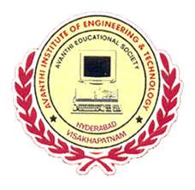

**AVANTHI INSTITUTE OF ENGINEERING AND TECHNOLOGY**

**(Approved by AICTE, Affiliated to J.N.T.U - KAKINADA, A.P)**

**(An NBA & NAAC Accredited Institution)**

**Makavarapalem, Narsipatnam Road,**

**Visakhapatnam Dist-531113.**

**(2014-2018)**